**j. Groom Wedding collection**

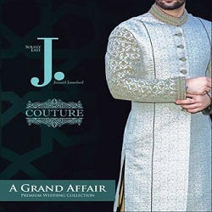

**SKY BLUE SHIRWANI WITH OLDEN WORK**

PKR6992.00

* Shirwani size: Medium
* Pajama: 2.5 Meters

**MORE INFORMATION:**

* color: Sky blue and golden
* Wear Type: Wedding
* Product Category: Groom shirwani
* Volume : Volume 4 2022
* Collection: Festive Affair '22
* Size: S, M , L ,XL
* Fabric: Banarsi
* Disclaimer: Due to the photographic lighting & different screen calibrations, the colors of the original product may slightly vary from the picture